WEEK 1

1. What do we call a center for learning?
2. Write any one element of weather.
3. Name one domestic animal that provides security.
4. Which school symbol encourages us to work hard?
5. In how many days did God create the world?
6. Why did God create the sun.
7. Who heads a municipality.
8. Draw and name one mean of road transport.
9. How is television helpful at school?
10. Why should people do physical exercise?

11a) Name two buildings found at school.

b) How useful is a kitchen at school.

12a) Where do we find God?

B) Draw and name two wild animals

|  |  |
| --- | --- |
|  |  |
|  |  |

13a) Who is a child?

b) Write two forms of child abuse

14a) What is a home?

b) Why should a home have the following

i)Rack

ii) Granary

15.a) What do we call natural land forms in an area?

b) State two examples of physical features.

WEEK TWO

1. In which division is our school found?
2. What title is given to pupils leaders?
3. Mention one benefit a school gets from its neighbours.
4. What is the difference between a map and a picture.
5. Write one occupation in our municipality.
6. What is fishing?
7. Write the Holy book for Christians.
8. Name this map symbol
9. Why should children be taken to school?
10. Give one example of a legend.

11a) State one example of a religious tradition.

b) Write any one symbol of each religion

i) Islam

ii) Christianity

12a) What is transport?

b) Give two causes of road accidents

13a) Use the diagram below to answer questions that follow;

N

1. Name the compass direction shown;

E

W

W…………….

Z……………

S

1. What is the name given to the four compass direction

14 State roles of the following in our community

1. Police officer
2. Fisher man
3. Nurse

15 Write three elements of a good map

i)

ii)

iii)

WEEK 3

1. What is culture?
2. Name one hill in kira municipality.
3. How are prefects helpful at school
4. 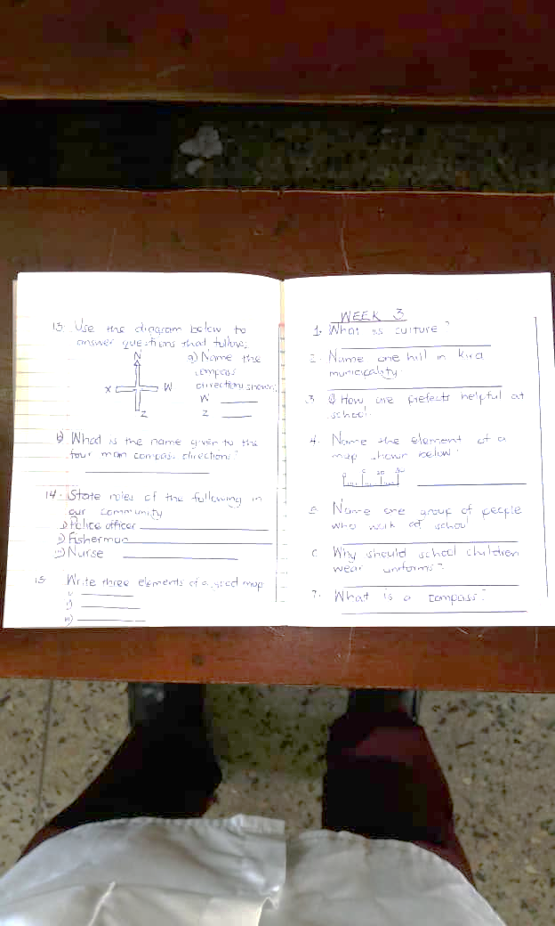Name the elements of a map shown below.
5. Name the group of people who work at school.
6. Why should school children wear uniforms?
7. What is a compass?
8. Write one way for Gods creation
9. What is the first Gospel book in the Bible.
10. Who baptized Jesus Christ?
11. a) In which municipality is our school found?

b)Name two parishes in kira municipality.

12 What is a tribe?

1. Mention two local tribes

13 Draw and name three map symbols

|  |  |  |
| --- | --- | --- |
|  |  |  |
|  |  |  |

14a) What is communication?

State any two ways of communicating to people

15a) What are legends?

Give one examples of a legend

How are legends helpful to people

week 4

1. Write one acceptable behavior at school
2. Why should a class have leaders?
3. Give one quality of a disciplined child?
4. Give the use of this item in our community.

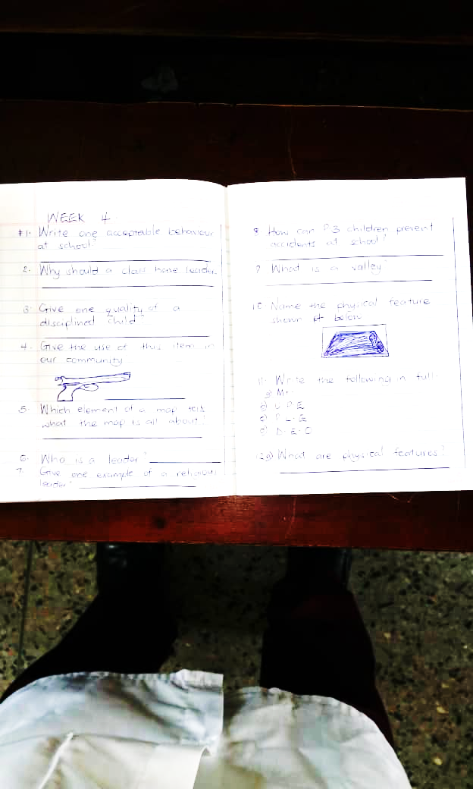

1. which element of a map tells what the map is all about?
2. Who is a leader?
3. Give one example of a religious leader.
4. How can P.3 children prevent accidents at school?
5. what is a valley?
6. Name the physical feature shown below.
7. Write the following in full
8. MT
9. U.P.E
10. P.L.E
11. D.E.O
12. a) What are physical features?

b) Name two physical features found in our municipality.

1. Give any two causes of insecurity in our community.

a…………………………..

b…………………………

1. What are domestic animals

b. Give two reasons why people rear animals.

1. What is a homestead?

b. Draw a homestead in the space below

**RESEARCH**

**Read about the following**

1. Occupations of people in our municipality and their importance.
2. Social services and their importance.
3. Challenges faced in accessing social services.